# Wage Penalties associated with Visible Minorities, in Canadian Labor Market

## Muhammad Ahmad

## November 2019

Acknowledgements:

I cannot express enough thanks for continued support and encouragement of Dr. Friesen Jane. I offer my sincere appreciation to all the effort she has put for providing an extraordinary learning experience.

I am very thankful to all my classmates. It would have been quite difficult for me to complete if Jack didn’t provide me assistance with code. Mason, Garrick and Jensen for being active in our course group chat. A special thanks to Tan for helping me in statistical modeling. Andrea and Jensen for encouragement and support.

Finally, I would like to thank Ian for cooperating with me and I am glad we could help each other in our respective papers.

## Introduction:

This study carries out a regression analysis of the earnings differentials between visible minorities and whites using 2011 Census data. Furthermore, I analyze how immigration status effect wage differential among visible minorities. The results estimate that given a person works 49-52 weeks full time in a year, visible minorities will earn around 18.97% less than non-immigrant white person in Canada, visible minority immigrants earn 24.52% more than white immigrants. Further decomposition explains these variations better. West Asian non-immigrants had the highest wage disadvantage with 22.54% lower wages as compared to native white people. Aboriginals earn 14.52% lower wages compared to native white ethnic group. Some of these differences can be explained by individual characteristics such as years from immigration, education level etc. I will explain the wage discrimination using log wages between whites and visible minorities by controlling characteristics of person such as whether a person is immigrant or not, level of education attained etc. It is important to analyze wage differential among ethnic groups to find out if there is discrimination among social groups and determine if there is need for policy change. I analyzed West Asian ethnic group as they have largest wage differential among other visible minority ethnicities. I also analyzed aboriginal ethnicity as they have been major focus of policies in Canada for uplifting people from poverty. Additionally, I will explore characteristics like location of education, education level and immigration status.

## Data and Methodology

As mentioned before the data is taken from Census Canada 2011. In my sample, I look at only 374,084 observation, this is because I choose to control for type of work, hence I have included observations only for people who worked full time and full year, additionally I have dropped any value with wage of one since it must be an error in dataset, considering minimum wage laws among all provinces, it’s likely that all observations with wage=1 and wage=0 are errors in dataset. Apart from that I have also dropped all the observations for which characteristics included in my model were not available i.e. whenever an observation didn’t have ethnicity defined, I dropped such observation.

My empirical model is:

$${\ln\left(wage\right)}_{i}=β_{1}+β_{2}NEWFi+β_{3}PEIi+β_{4}NSi+β_{5}NBi+β_{6}QBi+β_{7}ONTi+β_{8}MNi+β_{9}SKWi+β_{10}ALBi+β_{11}ENGi+β_{12}FRENi+β_{13}FRNi+β_{14}MALEi+β_{15}MARRi+β_{15}AGEi +β_{16}{AGE}_{60-64}i+β_{17}{AGE}_{55-59}i+β_{18}{AGE}_{50-54}i+β_{19}{AGE}_{45-49}i+β_{20}{AGE}_{40-44}i+β_{21}{AGE}_{30-34}i+β_{22}{AGE}_{25-29}i+β_{23}{AGE}_{20-24}i+β_{24}{AGE}_{18-19}i+β_{25}{AGE}_{15-17}i+β_{26}YIMi+β_{27}{YIM}^{2}+β_{27}LOCEDi+β_{28}DEDUCi+β_{29}HEDUCi+β_{30}UEDUCi+β_{31}ADEDUCi+β_{32}MVMi+β_{33}IMMGi+β_{34}IMMGi*MVMi+β_{35}ABi+β_{36}VMNi+β_{37}VMNi*IMMGi+β_{38}JPi+β_{39}JPi*IMMGi+β_{40}KOi+β_{41}KOi*IMMGi+β_{42}WAi+ β_{43}WAi*IMMGi+β_{44}SEAi+β_{45}SEAi*IMMGi+β_{46}ARBi+β_{47}ARBi*IMMGi+β_{48}LAi+β_{49}LAi*IMMG+β_{50}FLPi+β_{51}FLPi*IMMGi+β_{52}BLi+β_{53}BLi*IMMGi+β_{54}CHIi+β_{55}CHIi*IMMGi+β_{56}SAi+β_{57}SAi*IMMGi+β_{58}PRIi+β_{59}TTEi+β_{60}SSOi+β_{61}ACSi+β_{62}PUBi+β_{63}HELTi+β_{64}SCIi+β_{65}BFAi+β_{66}MANGi+ε_{i}$$

Where

|  |  |
| --- | --- |
| LWAGEᵢ | is Log of wage of ith person |
|  |  |
| NEWFᵢ | is a dummy variable if ith person lives in Newfoundland |
| PEIᵢ | is a dummy variable if ith person lives in Prince Edward Island |
| NSᵢ | is a dummy variable if ith person lives in Nova Scotia |
| NBᵢ | is a dummy variable if ith person lives in New Brunswick |
| QBᵢ | is a dummy variable if ith person lives in Quebec |
| ONTᵢ | is a dummy variable if ith person lives in Ontario |
| Mnᵢ | is a dummy variable if ith person lives in Manitoba |
| SKWᵢ | is a dummy variable if ith person lives in Saskatchewan |
| ALBᵢ | is a dummy variable if ith person lives in Alberta |
| ENGᵢ | is a dummy variable if ith person uses English as official language |
| FRNᵢ | is a dummy variable if ith person uses French as official language |
| MALEᵢ | is a dummy variable if ith person is Male |
| MARRᵢ | is a dummy variable if ith person is Married or Common law |
| AGE60_64ᵢ | is a dummy variable if ith person has AGE between 60-64 |
| AGE55_59ᵢ | is a dummy variable if ith person has AGE between 55-59 |
| AGE50_54ᵢ | is a dummy variable if ith person has AGE between 50-54 |
| AGE45_49ᵢ | is a dummy variable if ith person has AGE between 45-49 |
| AGE40_44ᵢ | is a dummy variable if ith person has AGE between 40-44 |
| AGE30_34ᵢ | is a dummy variable if ith person has AGE between 30-34 |
| AGE25_29ᵢ | is a dummy variable if ith person has AGE between 25-29 |
| AGE20_24ᵢ | is a dummy variable if ith person has AGE between 20-24 |
| AGE18_19ᵢ | is a dummy variable if ith person has AGE between 18-19 |
| AGE15_17ᵢ | is a dummy variable if ith person has AGE between 15-17 |
| YIMᵢ | is the number of years its been from Immigration |
|  |  |
| (YIMᵢ)^2 | is the squared value of YIM |
|  |  |
| LOCEDᵢ | is a dummy variable if ith person's Highest education outside Canada |
| DEDUCᵢ | Is a dummy variable if ith person's Highest education is Master or Doctorate |
| HEDUCᵢ | Is a dummy variable if ith person's Highest education is Highschool diploma or equivalent |
| UEDUCᵢ | Is a dummy variable if ith person's Highest education is University/college degree or diploma above it |
| ADEDUCᵢ | Is a dummy variable if ith person's highest education is Apprenticeship certificate and diploma level education |
| MVMᵢ | Is a dummy variable if ith person is Multiple Visible Minority |
| IMMG | Is a dummy variable if ith person is an immigrant |
| Immigrant |  |
| MVMᵢ*IMMGᵢ | Is the Interaction term between IMMG and MVM |
| Abᵢ | Is a dummy variable if ith person is Aboriginal |
| VMNᵢ | Is a dummy variable if ith person is visible Minorities not included any other ethnic group |
| VMNᵢ*IMMGᵢ | Interaction term between VMN and IMMG |
| JPᵢ | Is a dummy variable if ith person is Japanese |
| JPᵢ*IMMGᵢ | Is the Interaction term between Japanese and Immigrants |
| KOᵢ | Is a dummy variable if ith person is Korean |
| KOᵢ*IMMGᵢ | Is the Interaction term between KO and IMMG |
| WAᵢ | Is a dummy variable if ith person is West Asian |
| WAᵢ*IMMGᵢ | Is the Interaction term between WA and IMMG variables |
| SEAᵢ | Is a dummy variable if ith person is South-East Asian |
| SEAᵢ*IMMGᵢ | Is the Interaction term between variables SEA and IMMG |
| ARBᵢ | Is a dummy variable if ith person is an Arab |
| ARBᵢ*IMMGᵢ | Is the Interaction term between variables ARB and IMMG |
| LAᵢ | Is a dummy variable if ith person is Latin American |
| LAᵢ*IMMGᵢ | Is the Interaction term between variable LA and Immigrant |
| FLPᵢ | Is a dummy variable if ith person is Filipino |
| FLPᵢ*IMMGᵢ | Is the Interaction term between variable FLP and IMMG |
| BLᵢ | Is a dummy variable if ith person is Black |
| BLᵢ*IMMGᵢ | Is the Interaction term between variables BL and IMMG |
| CHIᵢ | Is a dummy variable if ith person is Chinese |
| CHIᵢ*IMMGᵢ | Is the interaction term between variables CHI and IMMG |
| SAᵢ | Is a dummy variable if ith person is South Asian |
| SAᵢ*IMMGᵢ | Is the Interaction term between variables SA and IMMG |
| PRIᵢ | Is a dummy variable if ith person has occupation unique to primary industry |
| TTEᵢ | Is a dummy variable if ith person has Trades, transport and equipment operators and related occupations |
| SSOᵢ | Is a dummy variable if ith person works in Sales and Service occupations |
| ACSᵢ | Is a dummy variable if ith person has occupation in ore related to Art, culture and sports |
| PUBᵢ | Is a dummy variable if ith person has social science, education, government service or religion as occupation |
| HELTᵢ | Is a dummy variable if ith person has occupation in or related to Health |
| SCIᵢ | Is a dummy variable if ith person has occupation in or related to applied sciences |
| BFAᵢ | Is a dummy variable if ith person has Business, finance and administrative occupations |
| MANGᵢ | Is a dummy variable if ith person has occupation related or in management |

εi Is the random error term

Identifying assumption:

E (εi | lwagei,NEWFi,PEIi,NSi,QBi,ONTi…..MANGi)= 0

The assumption requires that there are no unobserved factors that affect change in wage and are correlated with independent variables.

**Descriptive Statistics:**

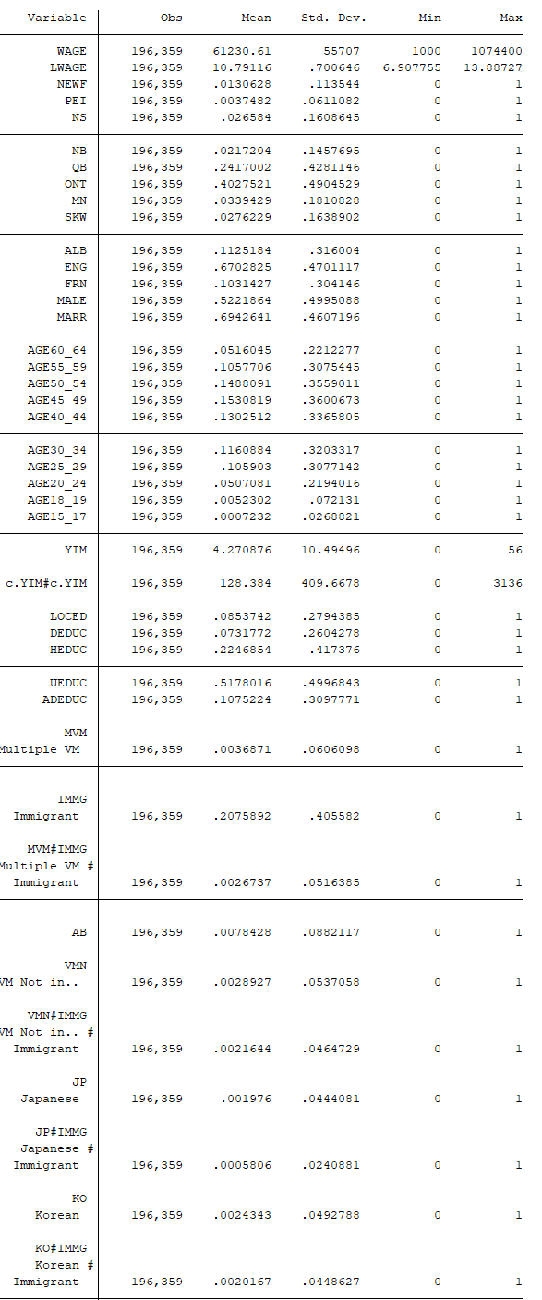

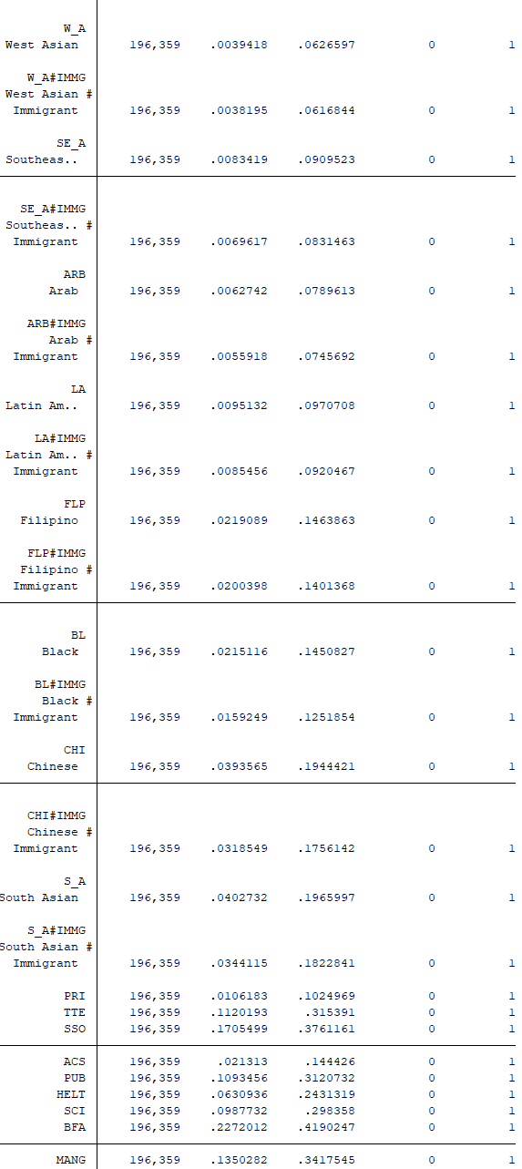

**Regression Results:**

First, I ran Regression with all visible minorities grouped as one dummy variable (AllVMIN) and without controlling for variables other than immigration status and sex, below are the results:

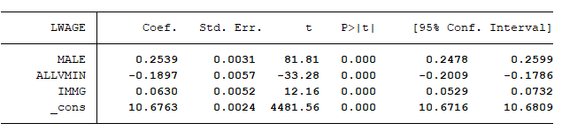

Second regression model contains interaction variable for all visible minority (ALLVMIN) and immigration status (IMMG), results were as follows:

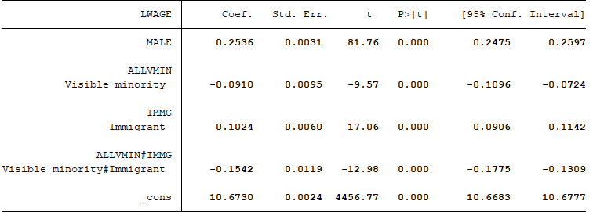

In my third regression model I look at year from immigration and immigration status without interaction term and results were as follows:



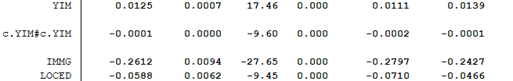

In my fifth regression model I added interaction term for LOCED (location of Education) and Immigration status (IMMG), and dropped interaction term of IMMG with visible minority Ethnicity

LWAGE 

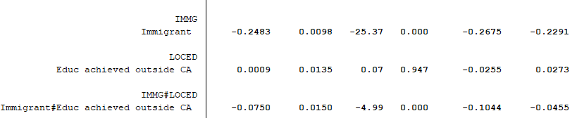

Fourth regression model is my main model where I control for every essential variable using given dataset, results were as follows:



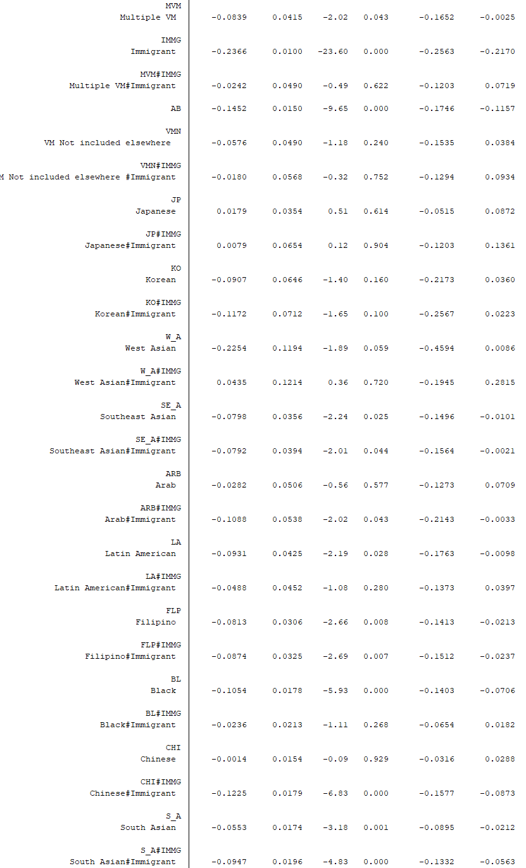

In my sixth regression I added interaction variable of aboriginal ethnicity and different education level, I also grouped all other minority ethnicities into one group with variable named as VNNO, and I interacted this with different education level so that I can get base as white ethnicity. The results were as follows:

LWAGE 

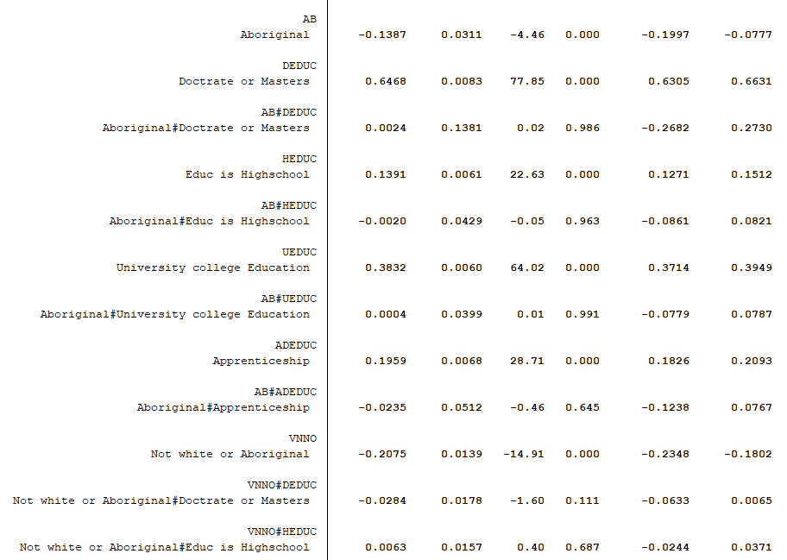

In my last regression I added interaction variable of West Asians ethnicity and different education level, I also grouped all other minority ethnicities into one group with variable named as NVM, and I interacted this with different education level so that I can get base as white ethnicity. The results were as follows:

**LWAGE** 

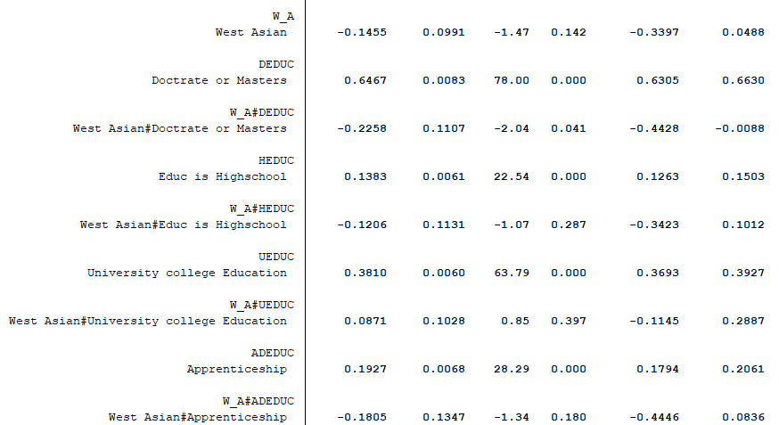

**Explanation of Results of Variables of Interest:**

Variable Location of Education (LOCED):

It appears that people who have received their post-secondary education outside Canada earn 6.12% lower wages compared to someone who has received their Post-Secondary Education in Canada. This is crucial because immigrants specially who are from developing countries whether the visible minority would have lower returns on education compared to education from Canadian institutions, potential reason is that employers are uncertain about quality of education outside Canada, hence it might not signal person abilities as good, and will be offered less wages. As there is correlation between being visible minorities and being an immigrant; immigrants are more likely to have education from outside Canada hence it is good idea to control for it. Interestingly though when I added interaction variable for LOCED and IMMG (whether person is an immigrant) in my third regression model, the results show that immigrants who achieved post-secondary education outside Canada, earned 7.41% below the immigrants that achieved their post-secondary education in Canada.

Variable Years from Immigration (YIM):

I included this variable since I think more a person is embedded in Canadian Culture, the person is more likely to get a higher paying job due to things like fluency of speaking English or French, networking effect etc. The longer person stays in Canada the more embedded he or she will be in Canadian culture. My model estimates that additional year from immigration will increase wage by 1.28% (using 4th or main regression). I also used the squared value of ‘years from immigration’ since I think that this effect should decrease over time, as after a while, may be a decade or two or so, person wouldn’t learn as much as he did in his early years about Canadian culture, hence there would be a decreasing function over time. However, the squared value of YIM, only decreases wages by 0.01% for an additional year from immigration, the change appears to be small and not significant, but since theoretically it makes sense, I didn’t consider removing it. Additionally, I tried to see if other polynomials or adding cubic and quartic functions would make any difference, but I didn’t see big enough change to consider them as significant values to be included in my model.

Variable Aboriginal (AB):

Regression model shows that Aboriginal minority have 14.52% lower wages as compared to native white ethnic group. However**,** when I added in interaction terms for highest education achieved and Aboriginal ethnicity variable, results show that Aboriginal people with university or college education earn 13.83% less than white people who have university or college level education, this is largest shrink in wage differential among other education levels of aboriginals. The wage difference certainly shrinks when accounted for education level, but the difference still exists.

West Asian (WA):

Our results in my main regression show that non-immigrants West Asian Minority earn 22.54% lower wage compared with native white ethnic group. West Asian immigrants earn 18.19% lower than white immigrants. My 7th regression model in which I take interaction values for Education levels and West Asian ethnicity, show that West Asians with university or college degree tend to earn 5.84% less than white ethnicity with college or university degree. This is largest shrink in wage differential among other West Asian ethnicity based on their education level. Hence, once again it seems that wage difference shrinks considering level of education, but discrimination remains.

## **Threats to identification**

I think one of the major concerns in my model will be not having experience variable, this was primarily due to lack of data, however I could have computed potential experience but that is only as good as Age variable playing proxy for experience. Despite that I think Age would work as proxy sufficiently for our Identification assumption to hold. My other concern was it would have been better if we had actual values for age. Also, one could argue that I took only full-time full year (full time 49-52 weeks a year), which could induce a selection bias but considering that the data provided didn’t have number of hours worked, there would have been more variation to deal with if I had not considered this sample.

## **Conclusion**

## My conclusion is that most of wage penalty due to ethnicity, shrinks by considering characteristics like education level, education location and occupation type as we see in case of West Asians and Aboriginal ethnicities. I have observed that more the number of individual person’s characteristics you can control for and add to your model, the more you can shrink down the wage differences. I think a research paper with more data than me could have more precise results. Least to say it would have been convenient if we had actual age of people rather groups were provided, and experience data would have been useful.

## References

Investigation of Earning Differentials Between Visible Minorities and Whites and Ethnic Groups: From Canadian Evidence by Lin, Hao, 2015-04-30. University of Ottawa. <https://ruor.uottawa.ca/handle/10393/32374>

## **Appendix**

## **Tables**

|  |  |  |  |  |  |
| --- | --- | --- | --- | --- | --- |
|  | (1) | (2) | (3) | (4) | (5) |
|  | LWAGE | LWAGE | LWAGE | LWAGE | LWAGE |
| MALE | 0.254*** | 0.254*** | 0.270*** | 0.269*** | 0.270*** |
|  | (0.00310) | (0.00310) | (0.00302) | (0.00302) | (0.00302) |
|  |  |  |  |  |  |
| ALLVMIN | -0.190*** |  |  |  |  |
|  | (0.00570) |  |  |  |  |
|  |  |  |  |  |  |
| IMMG | 0.0630*** |  | -0.261*** |  |  |
|  | (0.00518) |  | (0.00945) |  |  |
|  |  |  |  |  |  |
| 1.ALLVMIN |  | -0.0910*** |  |  |  |
|  |  | (0.00950) |  |  |  |
|  |  |  |  |  |  |
| 1.IMMG |  | 0.102*** |  | -0.237*** | -0.248*** |
|  |  | (0.00600) |  | (0.0100) | (0.00979) |
|  |  |  |  |  |  |
| 1.ALLVMIN#1.IMMG |  | -0.154*** |  |  |  |
|  |  | (0.0119) |  |  |  |
|  |  |  |  |  |  |
| NEWF |  |  | -0.129*** | -0.126*** | -0.128*** |
|  |  |  | (0.0122) | (0.0122) | (0.0122) |
|  |  |  |  |  |  |
| PEI |  |  | -0.234*** | -0.232*** | -0.234*** |
|  |  |  | (0.0219) | (0.0219) | (0.0219) |
|  |  |  |  |  |  |
| NS |  |  | -0.166*** | -0.164*** | -0.166*** |
|  |  |  | (0.00904) | (0.00904) | (0.00904) |
|  |  |  |  |  |  |
| NB |  |  | -0.184*** | -0.181*** | -0.183*** |
|  |  |  | (0.00993) | (0.00994) | (0.00993) |
|  |  |  |  |  |  |
| QB |  |  | -0.143*** | -0.141*** | -0.142*** |
|  |  |  | (0.00652) | (0.00652) | (0.00652) |
|  |  |  |  |  |  |
| ONT |  |  | 0.0105* | 0.0112* | 0.0105* |
|  |  |  | (0.00444) | (0.00444) | (0.00444) |
|  |  |  |  |  |  |
| MN |  |  | -0.0824*** | -0.0810*** | -0.0821*** |
|  |  |  | (0.00819) | (0.00819) | (0.00819) |
|  |  |  |  |  |  |
| SKW |  |  | 0.00680 | 0.00895 | 0.00728 |
|  |  |  | (0.00890) | (0.00890) | (0.00890) |
|  |  |  |  |  |  |
| ALB |  |  | 0.158*** | 0.159*** | 0.158*** |
|  |  |  | (0.00555) | (0.00555) | (0.00555) |
|  |  |  |  |  |  |
| ENG |  |  | -0.0401*** | -0.0402*** | -0.0399*** |
|  |  |  | (0.00452) | (0.00452) | (0.00452) |
|  |  |  |  |  |  |
| FRN |  |  | -0.112*** | -0.112*** | -0.112*** |
|  |  |  | (0.00550) | (0.00550) | (0.00550) |
|  |  |  |  |  |  |
| MARR |  |  | 0.0819*** | 0.0828*** | 0.0821*** |
|  |  |  | (0.00304) | (0.00304) | (0.00304) |
|  |  |  |  |  |  |
| AGE60_64 |  |  | 0.0362*** | 0.0376*** | 0.0369*** |
|  |  |  | (0.00697) | (0.00698) | (0.00698) |
|  |  |  |  |  |  |
| AGE55_59 |  |  | 0.101*** | 0.102*** | 0.102*** |
|  |  |  | (0.00550) | (0.00550) | (0.00550) |
|  |  |  |  |  |  |
| AGE50_54 |  |  | 0.124*** | 0.125*** | 0.124*** |
|  |  |  | (0.00503) | (0.00503) | (0.00503) |
|  |  |  |  |  |  |
| AGE45_49 |  |  | 0.108*** | 0.109*** | 0.108*** |
|  |  |  | (0.00498) | (0.00498) | (0.00498) |
|  |  |  |  |  |  |
| AGE40_44 |  |  | 0.0784*** | 0.0789*** | 0.0786*** |
|  |  |  | (0.00516) | (0.00516) | (0.00516) |
|  |  |  |  |  |  |
| AGE30_34 |  |  | -0.100*** | -0.102*** | -0.101*** |
|  |  |  | (0.00533) | (0.00533) | (0.00533) |
|  |  |  |  |  |  |
| AGE25_29 |  |  | -0.255*** | -0.257*** | -0.256*** |
|  |  |  | (0.00552) | (0.00553) | (0.00552) |
|  |  |  |  |  |  |
| AGE20_24 |  |  | -0.503*** | -0.505*** | -0.503*** |
|  |  |  | (0.00714) | (0.00714) | (0.00714) |
|  |  |  |  |  |  |
| AGE18_19 |  |  | -0.895*** | -0.895*** | -0.894*** |
|  |  |  | (0.0188) | (0.0188) | (0.0188) |
|  |  |  |  |  |  |
| AGE15_17 |  |  | -1.324*** | -1.326*** | -1.323*** |
|  |  |  | (0.0494) | (0.0494) | (0.0493) |
|  |  |  |  |  |  |
| YIM |  |  | 0.0125*** | 0.0128*** | 0.0121*** |
|  |  |  | (0.000715) | (0.000717) | (0.000719) |
|  |  |  |  |  |  |
| c.YIM#c.YIM |  |  | -0.000133*** | -0.000148*** | -0.000131*** |
|  |  |  | (0.0000139) | (0.0000140) | (0.0000139) |
|  |  |  |  |  |  |
| LOCED |  |  | -0.0588*** | -0.0612*** |  |
|  |  |  | (0.00622) | (0.00624) |  |
|  |  |  |  |  |  |
| DEDUC |  |  | 0.631*** | 0.629*** | 0.629*** |
|  |  |  | (0.00752) | (0.00753) | (0.00753) |
|  |  |  |  |  |  |
| HEDUC |  |  | 0.139*** | 0.139*** | 0.139*** |
|  |  |  | (0.00562) | (0.00562) | (0.00562) |
|  |  |  |  |  |  |
| UEDUC |  |  | 0.388*** | 0.387*** | 0.389*** |
|  |  |  | (0.00552) | (0.00552) | (0.00553) |
|  |  |  |  |  |  |
| ADEDUC |  |  | 0.194*** | 0.194*** | 0.195*** |
|  |  |  | (0.00635) | (0.00635) | (0.00636) |
|  |  |  |  |  |  |
| MVM |  |  | -0.0877*** |  | -0.0888*** |
|  |  |  | (0.0220) |  | (0.0220) |
|  |  |  |  |  |  |
| AB |  |  | -0.147*** | -0.145*** | -0.146*** |
|  |  |  | (0.0150) | (0.0150) | (0.0150) |
|  |  |  |  |  |  |
| VMN |  |  | -0.0565* |  | -0.0588* |
|  |  |  | (0.0248) |  | (0.0248) |
|  |  |  |  |  |  |
| JP |  |  | 0.0239 |  | 0.0240 |
|  |  |  | (0.0298) |  | (0.0298) |
|  |  |  |  |  |  |
| KO |  |  | -0.171*** |  | -0.172*** |
|  |  |  | (0.0271) |  | (0.0271) |
|  |  |  |  |  |  |
| W_A |  |  | -0.162*** |  | -0.164*** |
|  |  |  | (0.0216) |  | (0.0216) |
|  |  |  |  |  |  |
| SE_A |  |  | -0.129*** |  | -0.131*** |
|  |  |  | (0.0151) |  | (0.0151) |
|  |  |  |  |  |  |
| ARB |  |  | -0.106*** |  | -0.107*** |
|  |  |  | (0.0173) |  | (0.0173) |
|  |  |  |  |  |  |
| LA |  |  | -0.118*** |  | -0.120*** |
|  |  |  | (0.0142) |  | (0.0142) |
|  |  |  |  |  |  |
| FLP |  |  | -0.142*** |  | -0.141*** |
|  |  |  | (0.0101) |  | (0.0101) |
|  |  |  |  |  |  |
| BL |  |  | -0.108*** |  | -0.111*** |
|  |  |  | (0.00971) |  | (0.00972) |
|  |  |  |  |  |  |
| CHI |  |  | -0.0843*** |  | -0.0855*** |
|  |  |  | (0.00778) |  | (0.00779) |
|  |  |  |  |  |  |
| S_A |  |  | -0.119*** |  | -0.119*** |
|  |  |  | (0.00780) |  | (0.00780) |
|  |  |  |  |  |  |
| PRI |  |  | -0.0640*** | -0.0644*** | -0.0638*** |
|  |  |  | (0.0141) | (0.0141) | (0.0141) |
|  |  |  |  |  |  |
| TTE |  |  | 0.0578*** | 0.0572*** | 0.0581*** |
|  |  |  | (0.00713) | (0.00713) | (0.00713) |
|  |  |  |  |  |  |
| SSO |  |  | -0.145*** | -0.146*** | -0.145*** |
|  |  |  | (0.00671) | (0.00671) | (0.00671) |
|  |  |  |  |  |  |
| ACS |  |  | 0.0186 | 0.0166 | 0.0183 |
|  |  |  | (0.0110) | (0.0110) | (0.0110) |
|  |  |  |  |  |  |
| PUB |  |  | 0.166*** | 0.165*** | 0.165*** |
|  |  |  | (0.00758) | (0.00758) | (0.00758) |
|  |  |  |  |  |  |
| HELT |  |  | 0.192*** | 0.191*** | 0.192*** |
|  |  |  | (0.00826) | (0.00826) | (0.00826) |
|  |  |  |  |  |  |
| SCI |  |  | 0.256*** | 0.255*** | 0.257*** |
|  |  |  | (0.00746) | (0.00746) | (0.00746) |
|  |  |  |  |  |  |
| BFA |  |  | 0.0793*** | 0.0779*** | 0.0794*** |
|  |  |  | (0.00671) | (0.00671) | (0.00670) |
|  |  |  |  |  |  |
| MANG |  |  | 0.372*** | 0.370*** | 0.371*** |
|  |  |  | (0.00705) | (0.00705) | (0.00705) |
|  |  |  |  |  |  |
| 1.MVM |  |  |  | -0.0839* |  |
|  |  |  |  | (0.0415) |  |
|  |  |  |  |  |  |
| 1.MVM#1.IMMG |  |  |  | -0.0242 |  |
|  |  |  |  | (0.0490) |  |
|  |  |  |  |  |  |
| 1.VMN |  |  |  | -0.0576 |  |
|  |  |  |  | (0.0490) |  |
|  |  |  |  |  |  |
| 1.VMN#1.IMMG |  |  |  | -0.0180 |  |
|  |  |  |  | (0.0568) |  |
|  |  |  |  |  |  |
| 1.JP |  |  |  | 0.0179 |  |
|  |  |  |  | (0.0354) |  |
|  |  |  |  |  |  |
| 1.JP#1.IMMG |  |  |  | 0.00787 |  |
|  |  |  |  | (0.0654) |  |
|  |  |  |  |  |  |
| 1.KO |  |  |  | -0.0907 |  |
|  |  |  |  | (0.0646) |  |
|  |  |  |  |  |  |
| 1.KO#1.IMMG |  |  |  | -0.117 |  |
|  |  |  |  | (0.0712) |  |
|  |  |  |  |  |  |
| 1.W_A |  |  |  | -0.225 |  |
|  |  |  |  | (0.119) |  |
|  |  |  |  |  |  |
| 1.W_A#1.IMMG |  |  |  | 0.0435 |  |
|  |  |  |  | (0.121) |  |
|  |  |  |  |  |  |
| 1.SE_A |  |  |  | -0.0798* |  |
|  |  |  |  | (0.0356) |  |
|  |  |  |  |  |  |
| 1.SE_A#1.IMMG |  |  |  | -0.0792* |  |
|  |  |  |  | (0.0394) |  |
|  |  |  |  |  |  |
| 1.ARB |  |  |  | -0.0282 |  |
|  |  |  |  | (0.0506) |  |
|  |  |  |  |  |  |
| 1.ARB#1.IMMG |  |  |  | -0.109* |  |
|  |  |  |  | (0.0538) |  |
|  |  |  |  |  |  |
| 1.LA |  |  |  | -0.0931* |  |
|  |  |  |  | (0.0425) |  |
|  |  |  |  |  |  |
| 1.LA#1.IMMG |  |  |  | -0.0488 |  |
|  |  |  |  | (0.0452) |  |
|  |  |  |  |  |  |
| 1.FLP |  |  |  | -0.0813** |  |
|  |  |  |  | (0.0306) |  |
|  |  |  |  |  |  |
| 1.FLP#1.IMMG |  |  |  | -0.0874** |  |
|  |  |  |  | (0.0325) |  |
|  |  |  |  |  |  |
| 1.BL |  |  |  | -0.105*** |  |
|  |  |  |  | (0.0178) |  |
|  |  |  |  |  |  |
| 1.BL#1.IMMG |  |  |  | -0.0236 |  |
|  |  |  |  | (0.0213) |  |
|  |  |  |  |  |  |
| 1.CHI |  |  |  | -0.00138 |  |
|  |  |  |  | (0.0154) |  |
|  |  |  |  |  |  |
| 1.CHI#1.IMMG |  |  |  | -0.122*** |  |
|  |  |  |  | (0.0179) |  |
|  |  |  |  |  |  |
| 1.S_A |  |  |  | -0.0553** |  |
|  |  |  |  | (0.0174) |  |
|  |  |  |  |  |  |
| 1.S_A#1.IMMG |  |  |  | -0.0947*** |  |
|  |  |  |  | (0.0196) |  |
|  |  |  |  |  |  |
| 1.LOCED |  |  |  |  | 0.000896 |
|  |  |  |  |  | (0.0135) |
|  |  |  |  |  |  |
| 1.IMMG#1.LOCED |  |  |  |  | -0.0750*** |
|  |  |  |  |  | (0.0150) |
|  |  |  |  |  |  |
| _cons | 10.68*** | 10.67*** | 10.31*** | 10.31*** | 10.31*** |
|  | (0.00238) | (0.00239) | (0.0103) | (0.0103) | (0.0103) |
| *N* | 196359 | 196359 | 196359 | 196359 | 196359 |
| *R*2 | 0.039 | 0.040 | 0.304 | 0.304 | 0.304 |

Standard errors in parentheses

* *p* < 0.05, ** *p* < 0.01, *** *p* < 0.001

|  |  |  |
| --- | --- | --- |
|  | (6) | (7) |
|  | log function of wages of individuals | log function of wages of individuals |
| Newfoundland and Labrador as Location of work | -0.127*** | -0.131*** |
|  | (0.0123) | (0.0122) |
|  |  |  |
| Prince Edward as location of work | -0.231*** | -0.235*** |
|  | (0.0220) | (0.0219) |
|  |  |  |
| Nova Scotia as location of work | -0.164*** | -0.167*** |
|  | (0.00904) | (0.00902) |
|  |  |  |
| New Brunswick as location of job | -0.182*** | -0.185*** |
|  | (0.00994) | (0.00992) |
|  |  |  |
| Quebec as location of job | -0.148*** | -0.145*** |
|  | (0.00650) | (0.00649) |
|  |  |  |
| Ontario as location of Job | 0.00860 | 0.00948* |
|  | (0.00442) | (0.00441) |
|  |  |  |
| Manitoba as Location of job | -0.0851*** | -0.0855*** |
|  | (0.00819) | (0.00816) |
|  |  |  |
| Saskatchewan as location of job | 0.00623 | 0.00483 |
|  | (0.00890) | (0.00888) |
|  |  |  |
| ALberta as location of Job | 0.154*** | 0.156*** |
|  | (0.00555) | (0.00554) |
|  |  |  |
| People who can use only English as Language | -0.0420*** | -0.0408*** |
|  | (0.00453) | (0.00452) |
|  |  |  |
| People who can use only French as official language | -0.111*** | -0.112*** |
|  | (0.00551) | (0.00550) |
|  |  |  |
| dummy variable if person's Male | 0.271*** | 0.270*** |
|  | (0.00302) | (0.00302) |
|  |  |  |
| dummy variable if person's married or not | 0.0798*** | 0.0821*** |
|  | (0.00304) | (0.00303) |
|  |  |  |
| dummy variable if person's age b/w 60-64 | 0.0468*** | 0.0362*** |
|  | (0.00698) | (0.00697) |
|  |  |  |
| dummy variable if person's age b/w 55-59 | 0.110*** | 0.101*** |
|  | (0.00550) | (0.00550) |
|  |  |  |
| dummy variable if person's age b/w 50-54 | 0.132*** | 0.124*** |
|  | (0.00503) | (0.00503) |
|  |  |  |
| dummy variable if person's age b/w 45-49 | 0.114*** | 0.108*** |
|  | (0.00498) | (0.00498) |
|  |  |  |
| dummy variable if person's age b/w 40-44 | 0.0805*** | 0.0788*** |
|  | (0.00517) | (0.00516) |
|  |  |  |
| dummy variable if person's age b/w 30-34 | -0.103*** | -0.101*** |
|  | (0.00534) | (0.00533) |
|  |  |  |
| dummy variable if person's age b/w 25-29 | -0.258*** | -0.255*** |
|  | (0.00553) | (0.00552) |
|  |  |  |
| dummy variable if person's age b/w 20-24 | -0.502*** | -0.503*** |
|  | (0.00715) | (0.00714) |
|  |  |  |
| dummy variable if person's age b/w 18-19 | -0.890*** | -0.896*** |
|  | (0.0189) | (0.0188) |
|  |  |  |
| dummy variable if person's age b/w 15-17 | -1.323*** | -1.325*** |
|  | (0.0494) | (0.0493) |
|  |  |  |
| Number of years since Immigration | -0.00143** | 0.0125*** |
|  | (0.000501) | (0.000711) |
|  |  |  |
| Number of years since Immigration # Number of years since Immigration | 0.0000602*** | -0.000136*** |
|  | (0.0000119) | (0.0000138) |
|  |  |  |
| dummy variable if person's Highest education outside Canada or not | -0.155*** | -0.0699*** |
|  | (0.00562) | (0.00638) |
|  |  |  |
| Aboriginal | -0.139*** |  |
|  | (0.0311) |  |
|  |  |  |
| Doctorate or Masters | 0.647*** | 0.647*** |
|  | (0.00831) | (0.00829) |
|  |  |  |
| Aboriginal # Doctorate or Masters | 0.00242 |  |
|  | (0.138) |  |
|  |  |  |
| Educ is Highschool | 0.139*** | 0.138*** |
|  | (0.00615) | (0.00614) |
|  |  |  |
| Aboriginal # Educ is Highschool | -0.00200 |  |
|  | (0.0429) |  |
|  |  |  |
| University college Education | 0.383*** | 0.381*** |
|  | (0.00599) | (0.00597) |
|  |  |  |
| Aboriginal # University college Education | 0.000442 |  |
|  | (0.0399) |  |
|  |  |  |
| Apprenticeship | 0.196*** | 0.193*** |
|  | (0.00683) | (0.00681) |
|  |  |  |
| Aboriginal # Apprenticeship | -0.0235 |  |
|  | (0.0512) |  |
|  |  |  |
| Not white or Aboriginal | -0.207*** |  |
|  | (0.0139) |  |
|  |  |  |
| Not white or Aboriginal # Doctorate or Masters | -0.0284 |  |
|  | (0.0178) |  |
|  |  |  |
| Not white or Aboriginal # Educ is Highschool | 0.00632 |  |
|  | (0.0157) |  |
|  |  |  |
| Not white or Aboriginal # University college Education | 0.0788*** |  |
|  | (0.0144) |  |
|  |  |  |
| Not white or Aboriginal # Apprenticeship | 0.0396* |  |
|  | (0.0200) |  |
|  |  |  |
| If person has occupation unique to primary industry | -0.0637*** | -0.0650*** |
|  | (0.0141) | (0.0141) |
|  |  |  |
| If person in Trades, transport and equipment operator related occupation | 0.0579*** | 0.0570*** |
|  | (0.00716) | (0.00714) |
|  |  |  |
| if person in Sales and Services occupations | -0.147*** | -0.146*** |
|  | (0.00673) | (0.00671) |
|  |  |  |
| If people with occupation in Art, culture and sports | 0.0215 | 0.0188 |
|  | (0.0110) | (0.0110) |
|  |  |  |
| If People with social science, education, gov't service or religon as occupation | 0.170*** | 0.165*** |
|  | (0.00759) | (0.00757) |
|  |  |  |
| People in health Science sector | 0.194*** | 0.191*** |
|  | (0.00827) | (0.00825) |
|  |  |  |
| People with natural and applied sciences and related occupations | 0.256*** | 0.258*** |
|  | (0.00748) | (0.00746) |
|  |  |  |
| People with Business finance or Administration as occupation | 0.0810*** | 0.0792*** |
|  | (0.00673) | (0.00671) |
|  |  |  |
| People with management occupation | 0.374*** | 0.371*** |
|  | (0.00706) | (0.00705) |
|  |  |  |
| If a person is immigrant or not |  | -0.257*** |
|  |  | (0.00936) |
|  |  |  |
| West Asian |  | -0.145 |
|  |  | (0.0991) |
|  |  |  |
| West Asian # Doctrate or Masters |  | -0.226* |
|  |  | (0.111) |
|  |  |  |
| West Asian # Educ is Highschool |  | -0.121 |
|  |  | (0.113) |
|  |  |  |
| West Asian # University college Education |  | 0.0871 |
|  |  | (0.103) |
|  |  |  |
| West Asian # Apprenticeship |  | -0.181 |
|  |  | (0.135) |
|  |  |  |
| Not White nor West Asian |  | -0.134*** |
|  |  | (0.0132) |
|  |  |  |
| Not White nor West Asian # Doctrate or Masters |  | -0.0375* |
|  |  | (0.0173) |
|  |  |  |
| Not White nor West Asian # Educ is Highschool |  | 0.00447 |
|  |  | (0.0149) |
|  |  |  |
| Not White nor West Asian # University college Education |  | 0.0444** |
|  |  | (0.0137) |
|  |  |  |
| Not White nor West Asian # Apprenticeship |  | 0.00964 |
|  |  | (0.0190) |
|  |  |  |
| Constant | 10.31*** | 10.31*** |
|  | (0.0107) | (0.0106) |
| Observations | 196359 | 196359 |

Standard errors in parentheses